Task 1:
Program:
import java.util.*;
public class StringSimilarity {
private static int[] computeZArray(String s) {
int n = s.length();
int[] Z = new int[n];
int left = 0, right = 0;
for (int i = 1; i < n; i++) {
if (i <= right) {
Z[i] = Math.min(right - i + 1, Z[i - left]);
}
while (i + Z[i] < n && s.charAt(Z[i]) == s.charAt(i + Z[i])) {
Z[i]++;
}
if (i + Z[i] - 1 > right) {
left = i;
right = i + Z[i] - 1;
}
}
return Z;
}

// Function to calculate similarity sum
private static long stringSimilarity(String s) {
int[] Z = computeZArray(s);
long sum = s.length(); // similarity with itself
for (int val : Z) {
sum += val;
}
return sum;
}

public static void main(String[] args) {
Scanner sc = new Scanner(System.in);
int t = Integer.parseInt(sc.nextLine())
while (t-- > 0) {
String s = sc.nextLine().trim();
System.out.println(stringSimilarity(s));
}
sc.close();
}
}
Output:
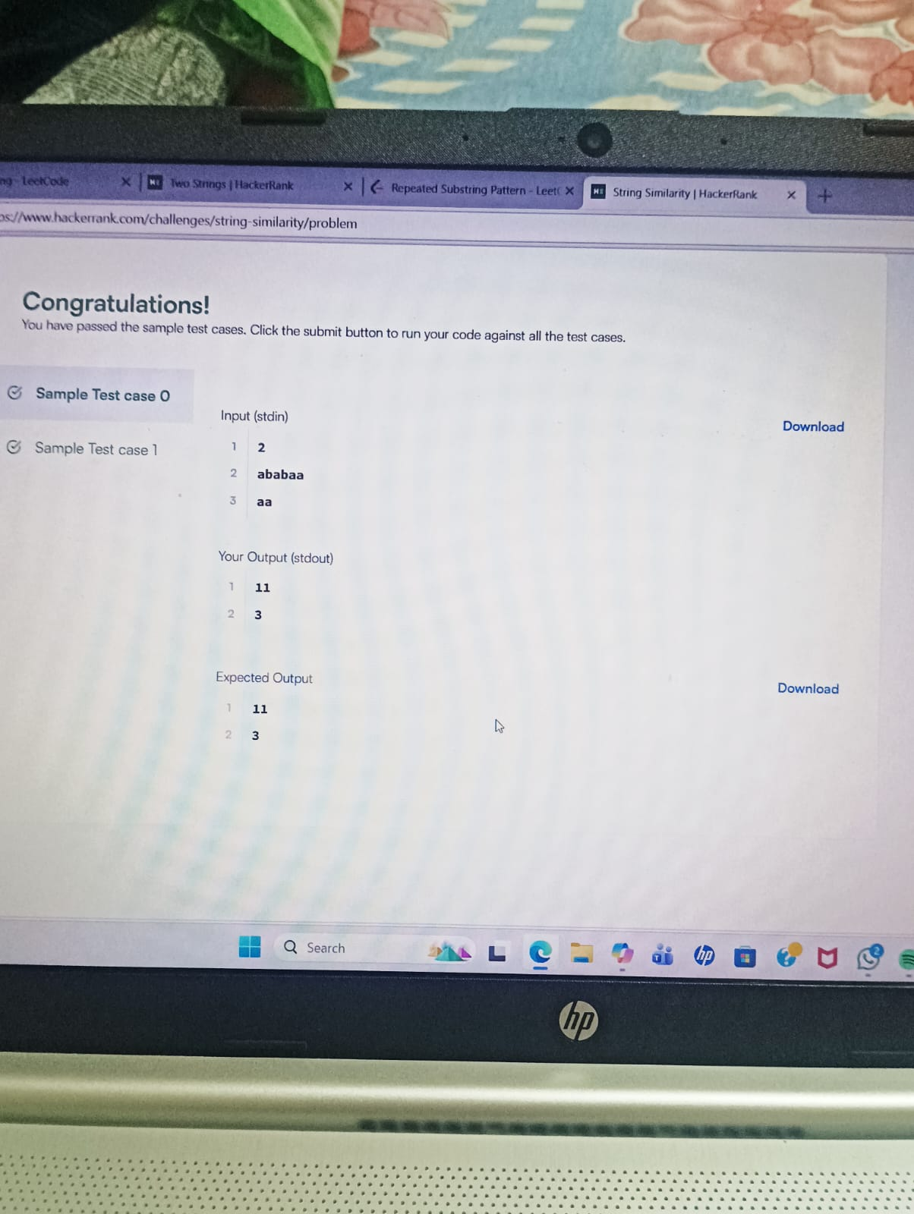

Task 2:
Program:
import java.util.*;
public class TwoStrings {
public static String twoStrings(String s1, String s2) {
// Use a HashSet to store characters of s1
Set<Character> set = new HashSet<>();
for (char c : s1.toCharArray()) {
set.add(c);
}
// Check if any character of s2 exists in s1
for (char c : s2.toCharArray()) {
if (set.contains(c)) {
return "YES";
}
}
return "NO";
}

public static void main(String[] args) {
Scanner sc = new Scanner(System.in);
int t = Integer.parseInt(sc.nextLine());

while (t-- > 0) {
String s1 = sc.nextLine().trim();
String s2 = sc.nextLine().trim();
System.out.println(twoStrings(s1, s2));
}

sc.close();
}
Output:
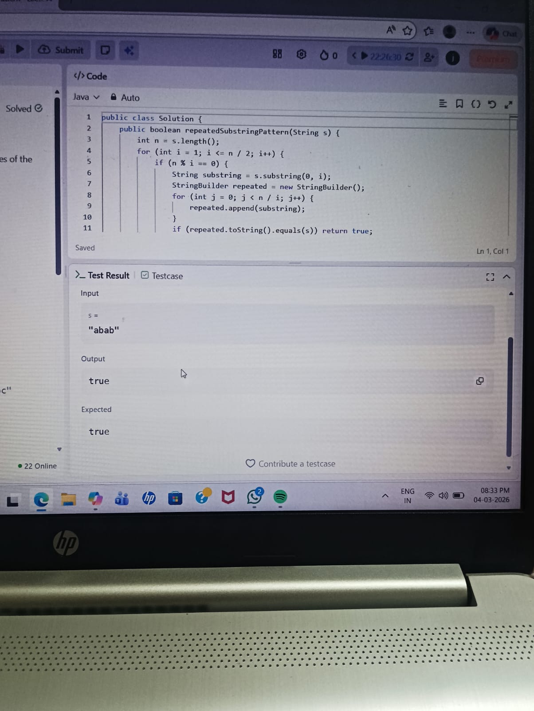

Task 3:
Program:
import java.util.*;
public class TwoStrings {
public static String twoStrings(String s1, String s2) {
Set<Character> set = new HashSet<>();
for (char c : s1.toCharArray()) {
set.add(c);
}
for (char c : s2.toCharArray()) {
if (set.contains(c)) {
return "YES";
}
}
return "NO";
}
public static void main(String[] args) {
Scanner sc = new Scanner(System.in);
int t = Integer.parseInt(sc.nextLine());
while (t-- > 0) {
String s1 = sc.nextLine().trim();
String s2 = sc.nextLine().trim();
System.out.println(twoStrings(s1, s2));
}
sc.close();
}
}
Outpu:
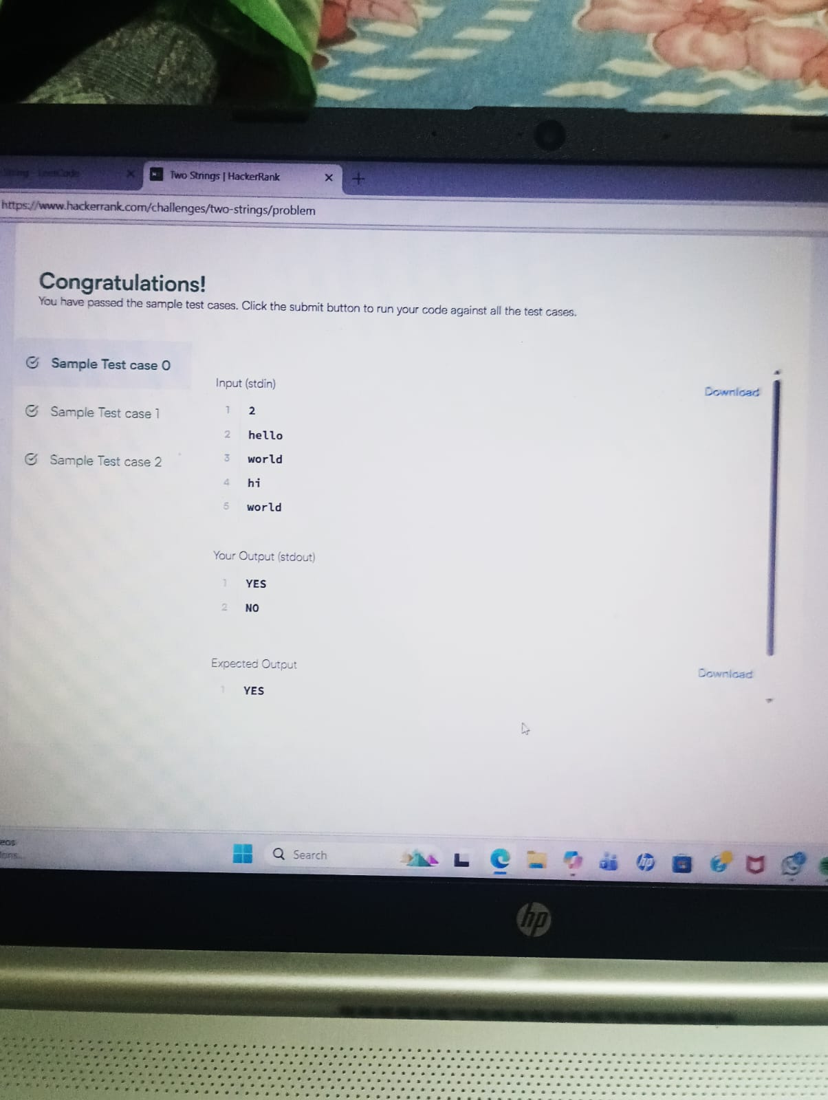

Task 4:
Program:
class Solution {
public boolean rotateString(String s, String goal) {
if (s.length() != goal.length()) {
return false;
}
String result = s + s;
return result.contains(goal);
}
}
Output:
